Summer Life Skills Group

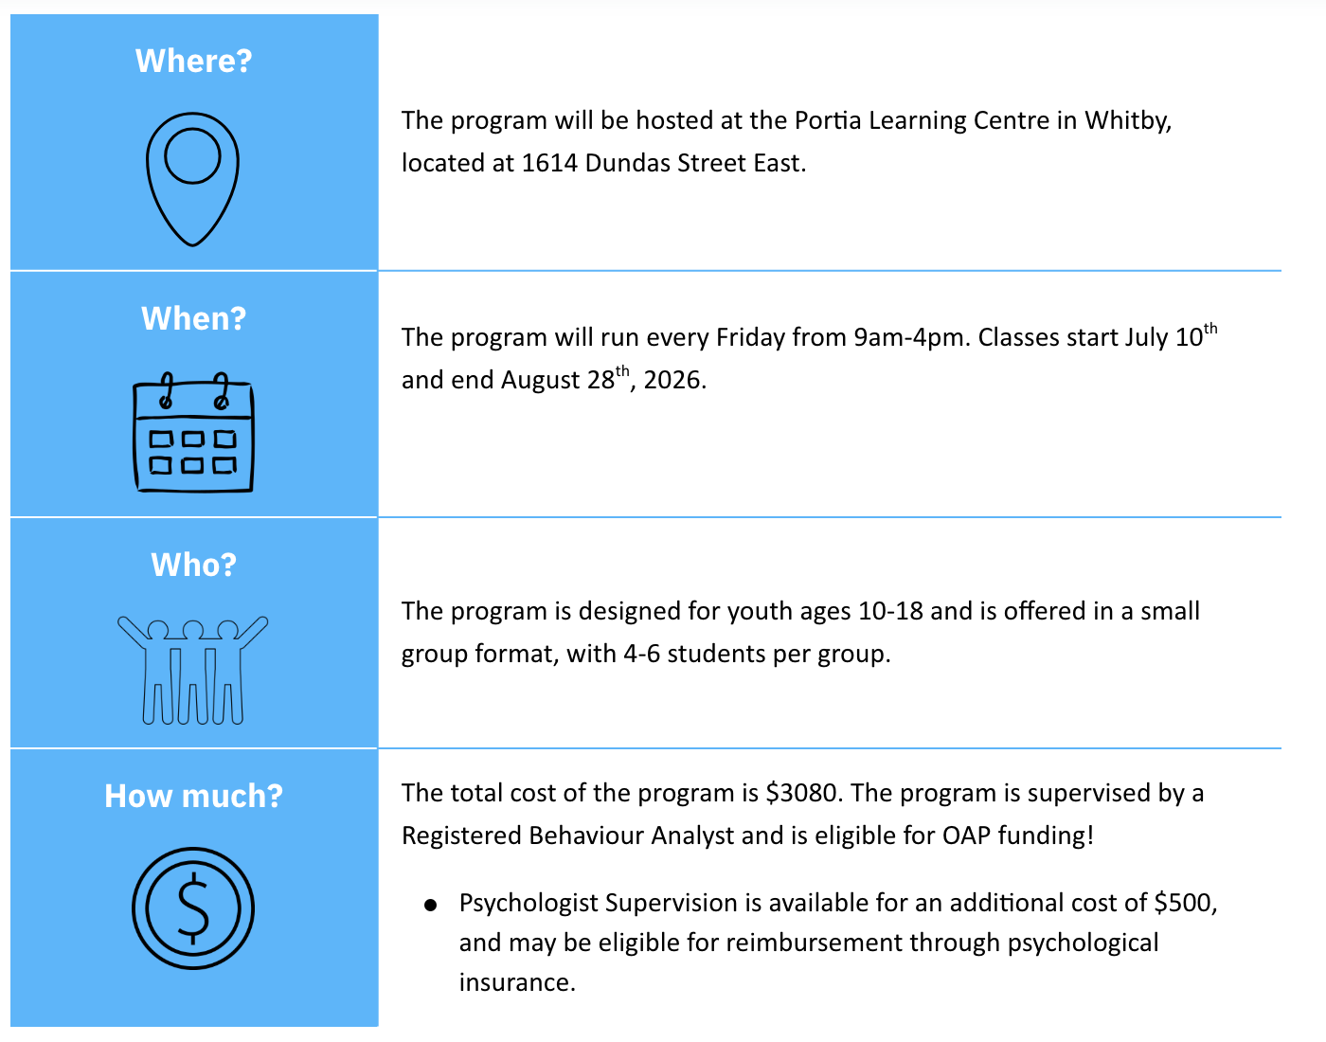

Program Overview
The Summer Life Skills Group is a structured, hands-on program designed to build independent living skills for adolescents and pre-teens.
The program focuses on teaching home-based skills including:
- Safe kitchen and appliance use
- Preparing simple meals and snacks
- Following multi-step directions
- Cleaning and organizing routines
- Building daily independence
This program is designed for children and adolescents ages 10–18 who would benefit from structured instruction in independent living and home management skills. Students will receive instruction, modeling, and hands-on practice.
The program is particularly appropriate for students with:
- Autism Spectrum Disorder (ASD)
- Developmental disabilities
- Adaptive functioning delays
- Executive functioning challenges
- Limited experience with household tasks
Students who will benefit most from this program typically demonstrate:
- Emerging readiness for independent living skill instruction
- Ability to participate in small-group learning activities
- Interest in food preparation or hands-on tasks
- Need for structured instruction in daily living routines
- Ability to remain engaged in a structured environment with minimal support
Students should be able to engage safely in a group environment with staff supervision and respond to safety instructions.
Participant Pre-Requisites
To ensure safety and effective participation in a kitchen-based instructional environment, participants should demonstrate the following prerequisite skills.

Communication Skills
Participants should demonstrate the ability to communicate basic needs using at least one of the following:
- Vocal language
- Augmentative or Alternative Communication (AAC) device
- Picture communication system
- Gestures or other functional communication methods
Participants should be able to follow simple one- to two-step instructions with or without prompting.

Behavioural Readiness
Participants should demonstrate:
- Ability to remain in a structured group setting for approximately 30 minutes at a time before accessing a short break
- Ability to follow basic safety instructions when prompted
- Ability to accept adult guidance and redirection
- No history of severe aggression or behaviors that may pose safety risks in a kitchen environment
Participants who require behavioral supports can still participate if appropriate staff ratios and safety plans are in place.

Instructional Readiness
Participants should demonstrate emerging ability to:
- Attend to demonstrations or modeling
- Imitate simple motor actions
- Follow visual supports or be able to learn with instructional support
- Participate in task-based learning activities

Motor Skills
Participants should demonstrate basic motor abilities including:
- Ability to hold and manipulate utensils or tools with support if necessary
- Ability to move light objects such as dishes or food items
- Ability to participate in simple cleaning tasks such as wiping surfaces
Adaptive tools or modified utensils may be used when appropriate.

Target Skill Domains

Safe Use of Kitchen Appliances
Participants will receive instruction in the safe operation of common household appliances, including:
- Microwave
- Toaster
- Toaster oven
- Dishwasher
Instruction will focus on identifying appliance components, safe operation procedures, timer use, and safe removal of heated items.

Basic Food Preparation
Participants will learn foundational food preparation skills including:
- Preparing simple snacks and meals
- Following visual recipes
- Measuring ingredients
- Assembling cold meals and snacks
Example activities may include preparing toast, sandwiches, fruit dishes, yogurt parfaits, microwave-based, toaster-oven based (e.g., pizzas) snacks.

Kitchen Safety
Participants will be taught essential kitchen safety skills, including:
- Safe dish and utensil handling
- Identifying hot surfaces
- Burn prevention strategies
- Food hygiene practices
- Cleaning spills and maintaining a safe workspace

Cleaning and Household Maintenance
Participants will practice maintaining clean living environments through structured cleaning routines.
Kitchen cleaning tasks may include:
- Wiping counters and tables
- Loading and unloading the dishwasher
- Washing dishes
- Cleaning kitchen appliances
Bedroom cleaning instruction may include:
- Making a bed
- Organizing personal belongings
- Picking up clutter
- Following a room-cleaning checklist

Following Visual Supports and Multi-Step Directions
Participants will learn to use visual supports to complete multi-step tasks independently, including:
- Visual schedules
- Task analysis cards
- Visual recipes
- Cleaning checklists
Instruction will focus on building independence in completing daily routines using visual prompts.

If you’re unsure if your child is a good fit for the program, contact us to schedule a free screening! Optional skill-based assessments are available prior to start of program in June, at an additional cost.

